Attribution Modeling and Budget Optimization

INFO7374 - Team 6

Assignment 3 - Part 2

# Linear Attribution Model:

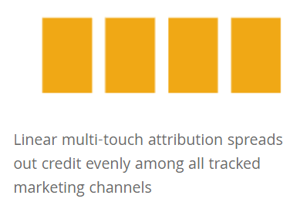

The linear model treats every touch point equally with all events playing a significant role in a user’s path to purchase. All events responsible for scaling a lead conversion are acknowledged fairly

<https://www.martechwiz.com/guide/beginners-guide-google-analytics-attribution-models/>

## Application

Linear attribution gives a more balanced look at the whole marketing strategy. This is a great model to analyze whether certain events are overvalued or undervalued.Since the linear model highlights all events, contribution of mid-funnel channels can be understood and sometimes patterns can be spotted in buyer journeys.

Tests for which channels can be cut can be performed in order to perfect marketing performance

<https://www.martechwiz.com/guide/beginners-guide-google-analytics-attribution-models/>

## Disadvantages

It assigns equal importance to everything. Some marketing strategies are more effective than others, and this model will not highlight the most effective strategies.

<https://agencyanalytics.com/blog/marketing-attribution-models>

# Time Decay Attribution Model:

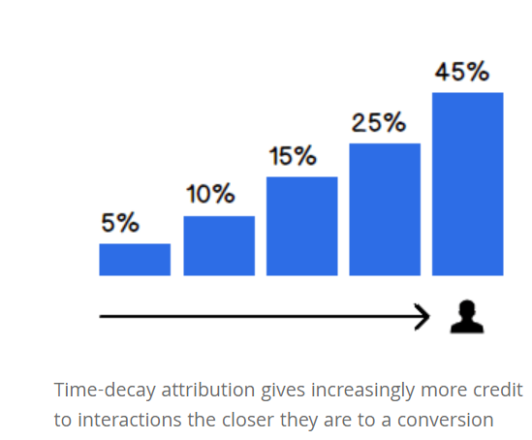

Time Decay attribution is similar to Linear attribution - it spreads out the value across multiple events. But unlike Linear attribution, the Time Decay model also takes into consideration *when* the touchpoint occurred.

Interactions that occur closer to the time of purchase have more value attributed to them. The first interaction gets less credit, while the last interaction will get the most.

## Application

Time decay is used by many marketers as it comes close to comprehensive attribution by defining the varying influence of individual channels. This model can be used to optimize the events which convert a lead while acknowledging other touch points.

This can apply this model in a few different scenarios:

* First, when buyer journey is longer (e.g. B2B).
* Second, to understand which interaction has the most influence with good traction and several leads.
* Third, to investigate the mismatch between high-quality traffic and low conversion performance

## Disadvantages

One big flaw in this model is devaluation of the first click. There are cases where the first touch may not matter much, like a time-sensitive promotion. Nonetheless, without a well-executed first interaction, the remaining journey may not be as persuasive.

[https://www.martechwiz.com/guide/beginners-guide-google-analytics-attribution-models](https://www.martechwiz.com/guide/beginners-guide-google-analytics-attribution-models/)

# U-shaped Attribution Model:

The U-shaped model is one of the attribution models for marketing teams which is similar to time decay, the model gives credit to all touch points while awarding the most to lead generation and conversion triggers

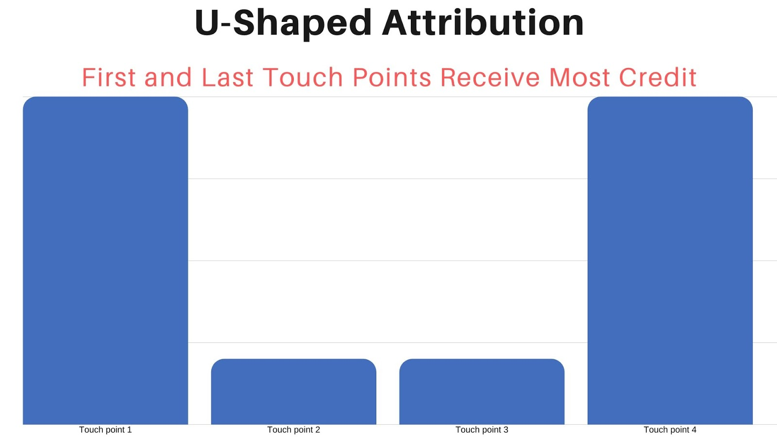

## Application

This model, assigns a credit point of 1 for the first and the last touch points and assigns a credit point of 0.5 for the intermediate touch points. Hence this model emphasizes the two touch points, the one which got the visitor/customer to the door and the one which lead to a touch point

## Disadvantages

The downside to this model is that it doesn’t consider marketing efforts beyond the conversion. This makes it an ideal model for lead reports or for marketing organizations that don’t do marketing targeted to prospects beyond the last stage, also the initial touch may not be that influential. So giving first touch the same weight as the event that closed a sale may twist the actual findings

[https://www.martechwiz.com/guide/beginners-guide-google-analytics-attribution-models](https://www.martechwiz.com/guide/beginners-guide-google-analytics-attribution-models/)

# 

# 

# 

# **Last Touch Attribution Model:**

The Last Touch model is the one which gives full credit to the touchpoint that drove a visitor to a conversion. This model is very straightforward as it gives as you don’t have to track or calculate the credit weight distribution

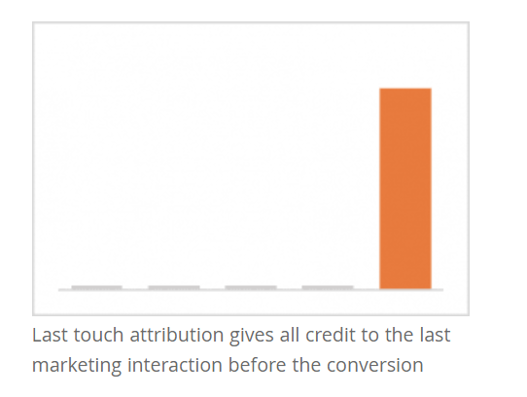

## Application

If you implement the Last Touch model, you are giving 100% credit to the last touchpoint and instantaneously identifying the marketing channel responsible for closing a sale. Which, in turn, can help you optimize that channel and increase revenue. In short, you get to focus on one event to accelerate lead generation without worrying about other touch points

## Disadvantages

Since this model focuses only on one final touchpoint, it really does not give you a clear picture of what is happening and hence fails to tell us on which channel to work on

<https://www.martechwiz.com/guide/beginners-guide-google-analytics-attribution-models/>

# **First Touch Attribution Model**

The First Touch model is the one which gives full credit to the touchpoint that drove a visitor to the website for the first time. This model is a very easy model to implement as importance is given to only the first touchpoints.

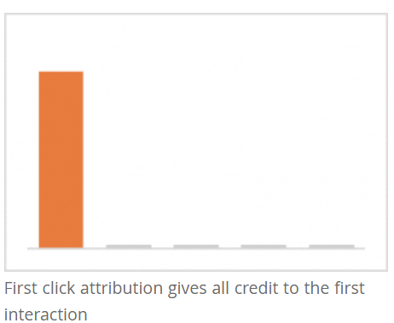

**Application**

100% credit for the first touchpoint and since all the weightage is given to a single point, this model gives you a great marketing insight into which channels drive your top of the funnel efforts

**Disadvantages**

First click fails to give you the whole story. With user journeys getting more diverse, ignoring other touch points will constrain your marketing analysis and may lead to channel bias and technology limitations.

<https://www.martechwiz.com/guide/beginners-guide-google-analytics-attribution-models/>

# Budget Optimization

According to grid dynamics, the weights produced by the 5 attribution models can be used to allocate the budget, and whichever model has the higher accuracy with better weights is considered as the best model.

The below graph shows the comparison of weights from the 5 different models:

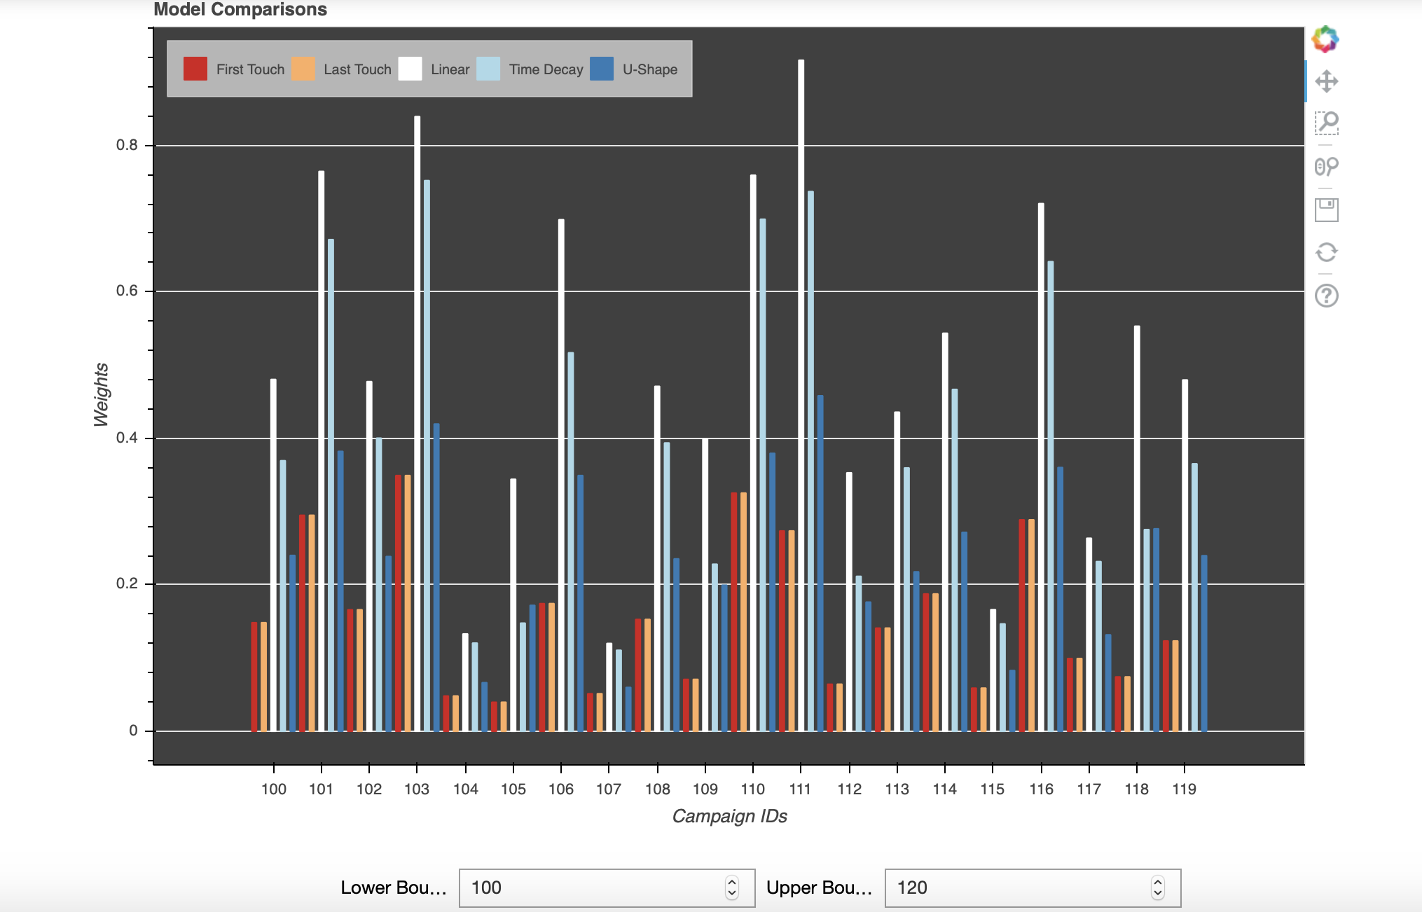

In order to validate the performance of the different models we need to make two assumptions:

1. Define the budget just as the number of events (impressions) that we can pay for, ignoring actual dollar costs
2. Assume that once a campaign runs out of money, all journeys that have more events associated with this campaign will never convert

These assumptions lead us to the simulation algorithm:

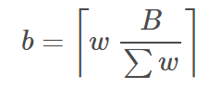

Where B is the Total Budget, w is attribution weights vector and the xt is events ordered by time. The simulation algorithm can be used not just to evaluate the attribution weights but also transformed weights from the actual weights wp for different values of parameter p.We have taken values from 0.1 to 2 for our evaluation as seen below in the graph

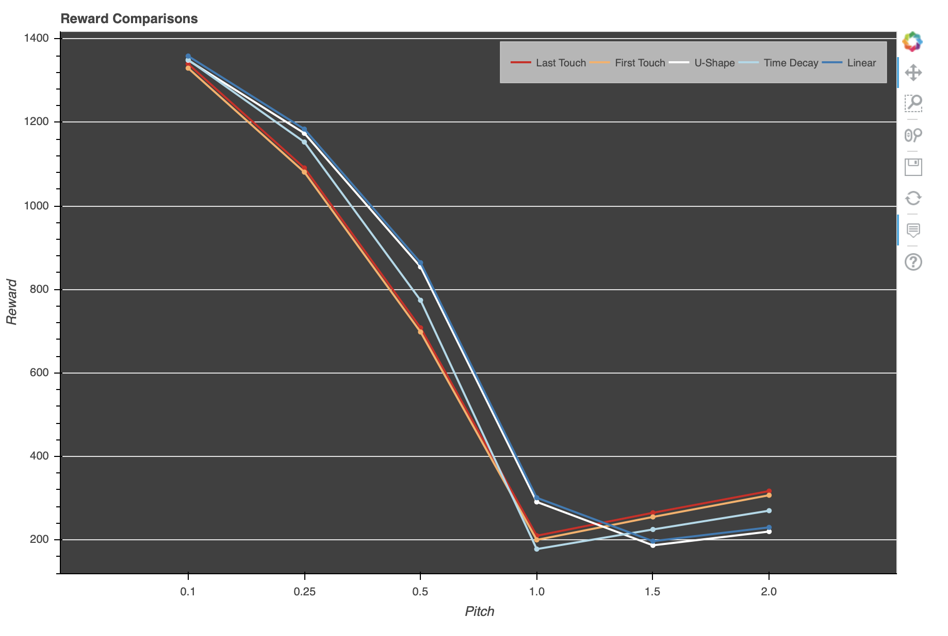

**Insights:**

1. The results confirm that for values below the actual attribution weight (i.e weights below 1), the **U-shaped** and **Linear** attribution model shows similar and best performance for budget allocation.
2. Whereas, for values above the actual weights (i.e weight above 1) the **FTA** and **LTA** attribution models show similar and better performance.
3. The **Time decay** attribution model shows a fair performance throughout the different parameter values.